Arbeitsblatt – Ruhemasse und dynamische Masse
Aufgabe: Schaut euch folgendes Video an www.youtube.com/watch?v=Hfam7ZAQ3Tg und bearbeitet die folgende Aufgabe!
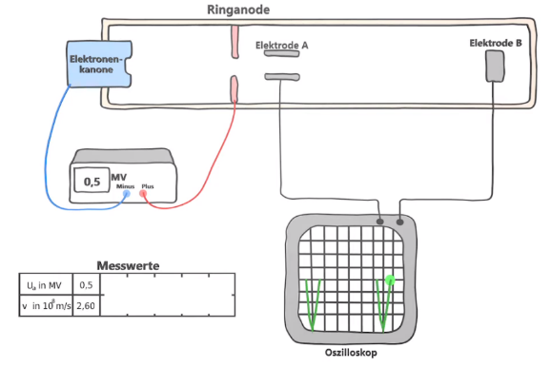
Aufgabe: Erklärt den Unterschied zwischen der Ruhemasse und der dynamischen Masse eines Körpers.
_______________________________________________
_______________________________________________
_______________________________________________
_______________________________________________
_______________________________________________
_______________________________________________















